Faculty of Nuclear Sciences and Physical Engineering
Department of Mathematics

Research Group: Methods of Algebra and Functional Analysis in Applications

Research program: Spectral and Dynamical Analysis of Nonrelativistic Quantum Systems

As a representative example of studied systems we can point out an analysis of a resonant cyclotron acceleration of charged massive particles by a time periodic singular flux tube. Assuming that charged particles are moving on a plane under the influence of a uniform magnetic field and driven by a periodically time-dependent Aharonov-Bohm flux, a remarkable resonance effect is observed. In case when the cyclotron frequency and the frequency of the singular magnetic flux obey a certain resonance condition, the particle trajectory resembles an expanding spiral curve. Moving along the
spiral, the particle periodically returns arbitrarily close to the vortex at which the singular flux tube intersects the plane. On the other hand, the radius of a circle of the spiral is proportional to
the square root of time and the particle energy grows linearly with time. An explicit formula for the acceleration rate has been derived in the framework of both classical and quantum mechanics,
respectively, in the papers:

J. Asch, T. Kalvoda, P. Šťovíček: Resonant cyclotron acceleration of particles by a time periodic singular flux tube, SIAM J. Appl. Math. 71 (2011) 829-853.

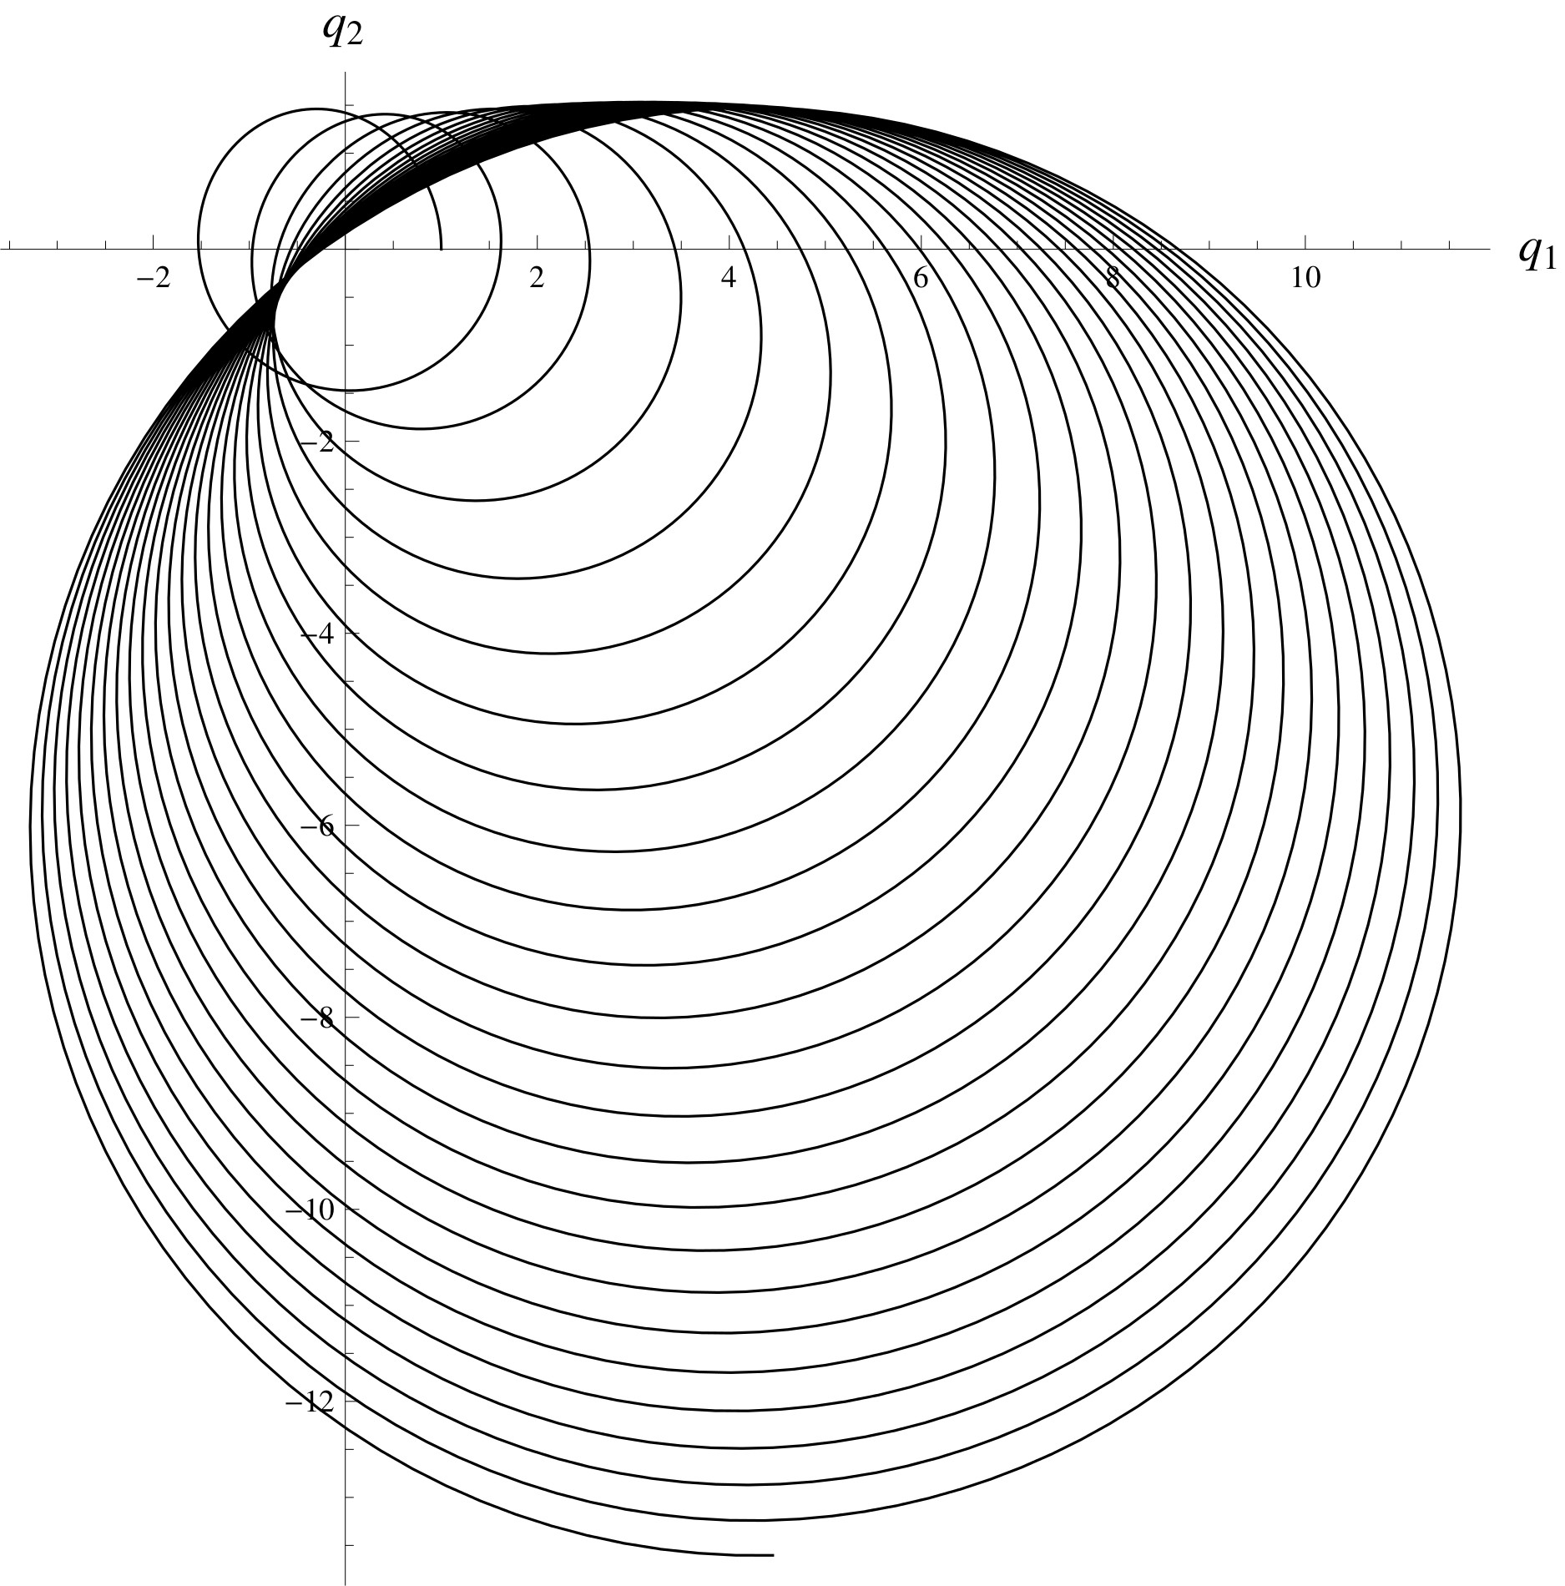
T. Kalvoda, P. Šťovíček: A charged particle in a homogeneous magnetic field accelerated by a time-periodic Aharonov-Bohm flux, Annals of Physics. 326 (2011) 2702-2716.

